Project Documentation Idea

Schema:

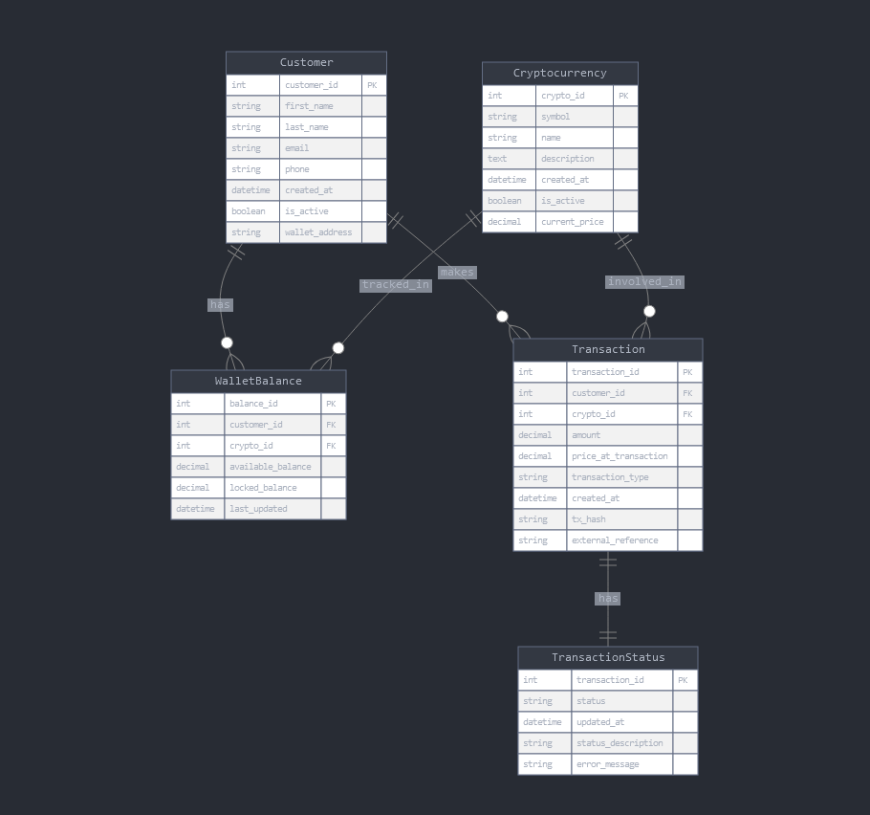

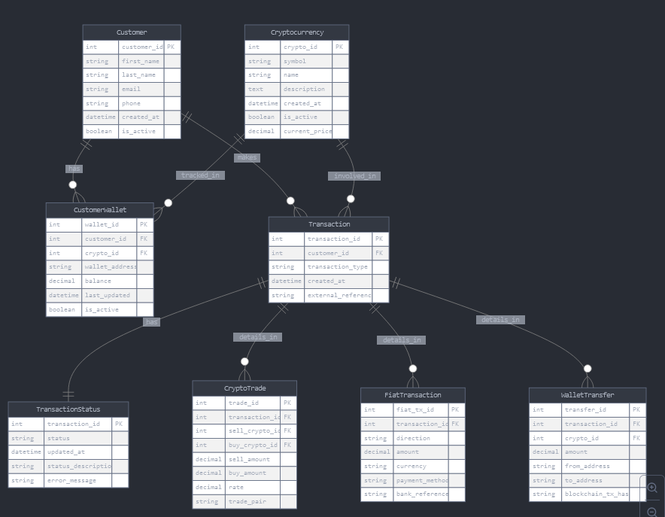

Possible exploration:

-- Get total portfolio value for each user

SELECT

u.first_name,

u.last_name,

SUM(w.value * c.price) as portfolio_value_usd

FROM user u

JOIN user_wallet w ON u.user_id = w.user_id

JOIN cryptocurrency c ON w.crypto_id = c.crypto_id

GROUP BY u.user_id, u.first_name, u.last_name;

-- Get detailed portfolio breakdown for a specific user (e.g., user_id = 1)

SELECT

c.crypto_name,

c.ticker,

w.value as quantity,

c.price as current_price,

(w.value * c.price) as total_value_usd

FROM user_wallet w

JOIN cryptocurrency c ON w.crypto_id = c.crypto_id

WHERE w.user_id = 1;

-- Get all transactions for a specific user with crypto details

SELECT

t.transaction_id,

c.ticker,

t.amount,

t.price_at_tx,

(t.amount * t.price_at_tx) as transaction_value_usd,

t.tx_hash

FROM transaction t

JOIN cryptocurrency c ON t.crypto_id = c.crypto_id

WHERE t.user_id = 1

ORDER BY t.transaction_id;

-- Get users who hold a specific cryptocurrency (e.g., BTC)

SELECT

u.first_name,

u.last_name,

w.value as btc_balance,

w.wallet_addr

FROM user u

JOIN user_wallet w ON u.user_id = w.user_id

JOIN cryptocurrency c ON w.crypto_id = c.crypto_id

WHERE c.ticker = 'BTC';